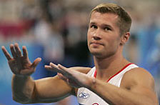  Alexei Nemov … | True | False
1. is the Russian swimmer.
2. won 12 Olympic medals.
3. didn’t finish his care as a sportsman.
4. is our contemporary.
5. is one of the most medaled gymnasts, male or female, of all time.

